**RR Lyrae** stars have the following properties:

* Period = 4 hours to 1 day
* Average Temperature = about 7000 Kelvin
* Average Luminosity = about 80 Lsun

RR Lyrae variables do not follow a strict period-luminosity relationship at visual wavelengths, although they do in the infrared K band

THE RR LYRAE PERIOD-LUMINOSITY RELATION. I. THEORETICAL CALIBRATION -

<https://iopscience.iop.org/article/10.1086/422916/pdf>

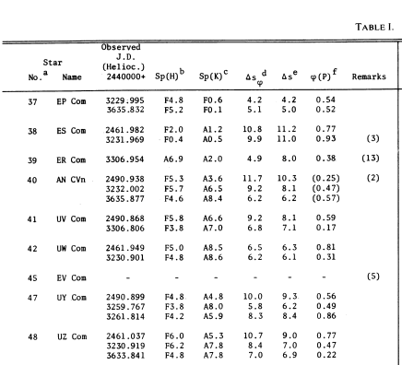

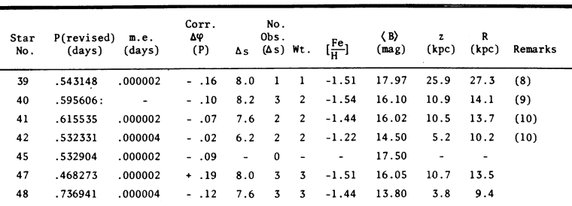

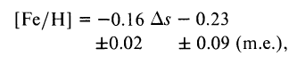

Ref: <http://articles.adsabs.harvard.edu/pdf/1979AJ.....84..993B>

 where *f* = 10[∝/Fe]

Can be useful: <https://iopscience.iop.org/article/10.1086/301407/pdf>

P-L for RR-Lyrae - <http://adsabs.harvard.edu/full/1998AstL...24..171F>

<https://academic.oup.com/mnrasl/article/440/1/L96/1396776>